PROJECT PROPOSAL

NIHVA TECHNOLOGIES PVT. LTD.
187, G-Block, Thermax chowk, Above Renault Showroom, MIDC
Chinchwad, Pune – 411019.

Customer Name | Ts Tech Sun Rajasthan Pvt Ltd
Project Name | Pillar mounting manipulator
Project Location | Rajasthan
Contact Person Name | Mr. Pankaj Khandelwal
Email Id | Pankaj_Khandelwal@tssrindia.com
Contact Number | +91-7891378001

Contact Person: Mr. Ravi Ranjan Prasad
Mob No.: 77095586333
Email id: ravi.prasad@nihva.com
Web: http://www.nihva.com

Project Title: Pillar mounting manipulator
Date: 7/2/2019
Dear Sir,

Thank you for the opportunity and trust shown on “NIHVA” your preferred partner for innovative solutions. This has reference to your above-mentioned requirements as well as our subsequent communication; please find below our best offer.

A. Requirement:
Require process is as below.

Process Flow Chart for manipulator

Availability of the Seat on DESK

GRIPPER will pick Seat from DESK .

USE PUSH button for clamping &manual Tilting.

ZERO gravity schematics has been used

Alignment and placed ON TROLLY at right position through gripper

After achieved desire position and placed operate de-clamp switch

After de-clamping, gripper will be at different place and will stand at given position.

Content of the system:
. SR NO. | Content
1 | Articulated arm type manipulator with zero gravity & Pneumatic gripper.
2 | Air booster + MIST dryer + FRL unit
3 | Parking brakes for all rotary joints.

Technical Specifications: -
1 | Weight (Kg.) - Capacity | 30kg
 | • Rotation | around main bearing joint on trolley, secondary rotation joint at horizontal arm, and final vertical gripper arm.
 | • Brakes at rotary joint | Brakes actuate in case of loss of air.
2 | Safety Features
A) In case of loss of air, component will not get released, in case of false
operation of release switch, equipment first comes down to find a surface and then de-clamps.
 | B) No sudden jerks in case of sudden pressure rise or fall .
 | C) Component remains in clamped condition though there is a loss of air supply.

Steel structure, I Beam etc. construction – All the necessary steel construction will be the responsibility of the customer. Foundation for the equipment is considered in scope of the customer. All civil works are exclusions for this offer.

We are proposing all standard make pneumatic elements:

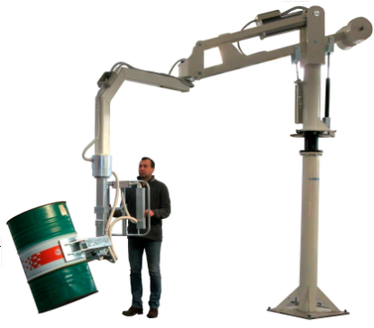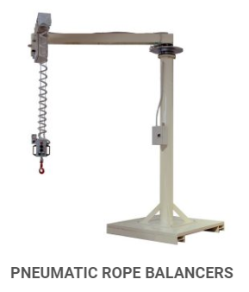
1. Industrial Manipulator 2. Pneumatic Manipulator
Sr no | Description | Qty | Unit | Rate in INR | Net Amount  INR
1 | Design, Mfg. & Supply, Installation & Commissioning of Manipulator for 40 Kg Seat | 1 | No | 12,50,000 | 12,50,000
2 | Design, Mfg. & Supply, Installation & Commissioning of Pneumatic operated GRIPPER
3 | Mist Dry + FR + Air Tank
Total Cost |  |  |  |  | 12,50,000
GST PUNE: 27AAECN0437H1ZM | Amount in Words:  Rupees Twelve Lacs Fifty Thousand Only
HSN Code: 84289090 | Amount in Words:  Rupees Twelve Lacs Fifty Thousand Only

E. Drawings Training and warranty

Drawing:
We will issue a full set of drawings for approval within 2 weeks of receiving the confirmed order and finalized design details.

Training:
After installation of the Manipulator system, we will train the Clients personnel in the operation and basic maintenance, including the understanding of the error codes on the control system (if applicable).

Warranty:
- The warranty period is twelve months from the date of installation and commissioning.
- If a defect arises within the warranty period stated, which is attributable to faulty design,
- materials or installation workmanship the product will be repaired at our discretion without charge.
- This guarantee is subject to proper use of the product and assumes that the product is regularly serviced and maintained by skilled personnel in accordance with the operation and maintenance instructions supplied.

- Maintenance & Service Agreement:
We would suggest that you take advantage of a maintenance and service agreement on the NIHVA products, which will guarantee trouble free operation and speed of response in an emergency. Customized proposals are available on request.
We are pleased to inform that we also undertake AMC for all of our

products & for any of your existing facilities.

Maintenance and service aren’t about what you get. They’re about what

you avoid: failures, losses and unplanned interruptions.

- Client Scope:
- Unloading from truck placement on site.

- Exiting/Repair/ Modification/ Refurbishment charges will be extra.

- Steel structure, I Beam and Foundation etc.

- The foundations for installation must be dry and the concrete must have hardened.

- Any civil work if required will be in client scope

G. Terms and Conditions: -

- Price : Ex. Works Pune

- P & F : 3 % Extra at the time of delivery.

- Freight Notes : Extra as applicable.

- Delivery : Within 6-7 weeks from date of receipt of
confirmed purchase order, advance payment,
drawing approval.

- Payment Terms : 80% advance along with confirmed purchase
order balance before dispatch.

- Insurance : Extra as applicable.

- GST : As Applicable on total supply value.

- Validity : 15 days from date of quotation.

9.Warranty : 12 months from date of supply.

- DAP : need client personally to check Manipulator

Please feel free to contact Mr. Ravi Ranjan Prasad on 7709586333 for any further clarification in this concern.

With Best Regards,
Ulka Auti
For NIHVA Technologies Pvt Ltd

